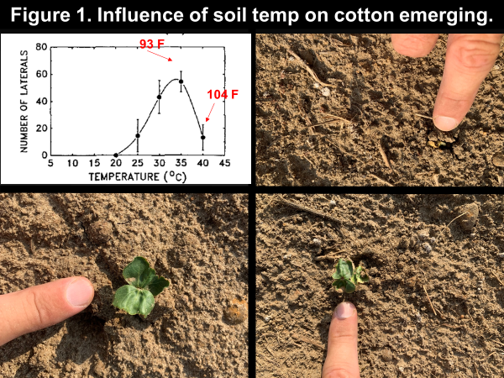
Heat or Herbicides? (Culpepper) Next week is shaping up to be a challenging week for cotton planting, similar to late May of 2019. Remember that soil temperatures greatly influence cotton emergence, Figure 1 includes a graph from a USDA manuscript sharing the relationship of lateral cotton root development as influenced by soil temperature (McMichael and Burke, Environmental and Experimental Botany, Vol 34, I added the F temperatures to their graph). Take special note the highest soil temperature that they studied was 104 F; next week we could easily exceed 115 F if predicted air temperature and lack of cloud predictions are accurate. Back in 2019, most blamed herbicides for the lack in cotton stand when in fact most issues were a result of high soil temperatures. Thus, Figure 1 also shares different levels of visual symptoms of cotton damage from hot soils (pictures from no-herbicide control plots). Any factor cooling soils may have a positive influence. For example, one of Camp Hands graduate projects conducted during late May of 2019 noted 35% better stands with a rye cover crop compared to tilled systems; although stand was reduced in both systems.

